COMPUTE THE PRODUCT OF LIST ELEMENTS AND FILTER EVEN NUMBERS

PROGRAM

def double(n):
return n*2
numbers = [5,6,7,8]
result = map(double,numbers)
print(list(result))
import functools
# define a list of numbers
numbers = [1, 2, 3, 4]
# use reduce to compute the product of list elements
product = functools.reduce(lambda x, y: x * y, numbers)
print("Product of list numbers:", product)
# define a function to check if a number is even
def is_even(n):
return n%2==0
#define a list of numbers
numbers =[1,2,3,4,5,6,7,8,9,10,11,12]
# use filter to filter out even numbers
even_numbers = filter(is_even,numbers)
print("Even numbers:",list(even_numbers))

OUTPUT:

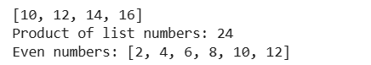

COUNT WORD FREQUENCY IN TEXT DATA

PROGRAM

from collections import defaultdict # Sample text data
text_data = [ "Hello world",
"Hello from the other side", "Hello there",
"Hello world from Student","Hello world from Faculty"]
# Map function
def map_function(line):
# Splitting the line into words
words = line.split()
# Emitting a key-value pair (word, 1) for each word
return [(word, 1) for word in words]
# Reduce function
def reduce_function(mapped_data):
# Using a dictionary to accumulate word counts
word_count = defaultdict(int)
for word, count in mapped_data:
word_count[word] += count
return word_count
# Step 1: Map step
mapped_data = []
for line in text_data:
mapped_data.extend(map_function(line))
# Step 2: Reduce step
word_count = reduce_function(mapped_data)
# Output the word count
print("Word Count:")
for word, count in word_count.items():
print(f"{word}: {count}")

OUTPUT:

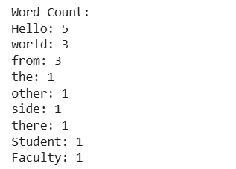

SUM OF NUMBERS

PROGRAM

# Sample list of numbers
numbers = [20, 40, 60, 80, 100]

# Map function
def map_function(number):
# Emit a key-value pair ("number", number) for each number
return [("number", number)]

# Reduce function
def reduce_function(mapped_data):
# Initialize a counter for the sum of numbers
total_sum = 0
for key, value in mapped_data:
if key == "number":
total_sum += value
return total_sum

# Step 1: Map step
mapped_data = []
for number in numbers:
mapped_data.extend(map_function(number))

# Step 2: Reduce step
total_sum = reduce_function(mapped_data)

# Output the total sum
print(f"Total Sum: {total_sum}")

OUTPUT:
Total Sum: 300

COUNT LINES IN TEXT DATA

PROGRAM

from collections import defaultdict
# Sample text data (each item represents a line)
text_data = [
"Hello world",
"Hello from the other side",
"Hello there",
"Hello world from Student",
"Hello",
"Happy Learning"
]
# Map function
def map_function(line):
# Emit a key-value pair ("line", 1) for each line
return [("line", 1)]

# Reduce function
def reduce_function(mapped_data):
# Initialize a counter for the number of lines
line_count = 0
for key, count in mapped_data:
if key == "line":
line_count += count
return line_count

# Step 1: Map step
mapped_data = []
for line in text_data:
mapped_data.extend(map_function(line))

# Step 2: Reduce step
line_count = reduce_function(mapped_data)

# Output the line count
print(f"Line Count: {line_count}")

OUTPUT:

Line Count: 6

COMPUTE DESCRIPTIVE STATISTICS

PROGRAM

from collections import defaultdict
from statistics import median, mode, variance, stdev
# Sample list of numbers
numbers = [10, 20, 20, 30, 40, 50, 50, 50, 60, 70]
# Map function
def map_function(number):
# Emit key-value pairs for each number
return [("sum", number), ("count", 1), ("number", number)]
# Reduce function
def reduce_function(mapped_data):
# Initialize variables for sum, count, and a list of numbers for median/mode
total_sum = 0
total_count = 0
number_list = []
frequency = defaultdict(int)
# Aggregate data
for key, value in mapped_data:
if key == "sum":
total_sum += value
elif key == "count":
total_count += 1
elif key == "number":
number_list.append(value)
frequency[value] += 1
# Calculate mean
mean_value = total_sum / total_count if total_count != 0 else 0
# Calculate median
median_value = median(number_list) if number_list else None
# Calculate mode
mode_value = max(frequency, key=frequency.get) if frequency else None
# Calculate variance and standard deviation
variance_value = variance(number_list) if len(number_list) > 1 else 0
stddev_value = stdev(number_list) if len(number_list) > 1 else 0
return mean_value, median_value, mode_value, variance_value, stddev_value

# Step 1: Map step
mapped_data = []
for number in numbers:
mapped_data.extend(map_function(number))

# Step 2: Reduce step
mean_value, median_value, mode_value, variance_value, stddev_value = reduce_function(mapped_data)

# Output the results
print(f"Mean: {mean_value}")
print(f"Median: {median_value}")
print(f"Mode: {mode_value}")
print(f"Variance: {variance_value}")
print(f"Standard Deviation: {stddev_value}")

OUTPUT:
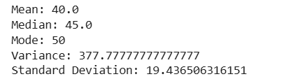

BOX-PLOTS AND HISTOGRAM FOR NUMERICAL VARIABLES

PROGRAM

import pandas as pd
import numpy as np
import matplotlib.pyplot as plt
# Generate a synthetic multivariate dataset
np.random.seed(0)
data = pd.read_csv(r"C:\Users\Student\Downloads\tested.csv")
# Define MapReduce-like functions
def mapper(data):
"""Map step: Computes statistics for each numerical column."""
stats = {}
for column in data.select_dtypes(include=[np.number]).columns:
stats[column] = {
'mean': data[column].mean(),
'std': data[column].std(),
'min': data[column].min(),
'max': data[column].max(),
'q1': data[column].quantile(0.25),
'median': data[column].median(),
'q3': data[column].quantile(0.75),}
return stats
def reducer(stats):
"""Reduce step: Combine statistics into a single DataFrame.""" returnpd.DataFrame(stats).T
def plot_data(data):
"""Function to plot histograms and boxplots for each numerical column."""
for column in data.select_dtypes(include=[np.number]).columns:
plt.figure(figsize=(12, 5))
# Boxplot plt.subplot(1, 2, 1)
plt.boxplot(data[column])
plt.title(f'Boxplot of {column}') # Histogram
plt.subplot(1, 2, 2)
plt.hist(data[column], bins=30, alpha=0.7)
plt.title(f'Histogram of {column}')
plt.show()
# Main execution
if name == ' main ':
# Step 1: Map
stats = mapper(data)
# Step 2: Reduce result = reducer(stats)
# Print summary statistics
print("Summary Statistics:")
print(result)
# Step 3: Plot data plot_data(data)

OUTPUT :
Summary Statistics:
meanstd min max q1 median \
PassengerId 1100.500000 120.810458 892.00 1309.0000 996.2500 1100.5000

Survived | 0.363636 0.481622 |  | 0.00 | 1.0000 0.0000 0.0000
Pclass | 2.265550 | 0.841838 | 1.00 | 3.0000 1.0000 | 3.0000
Age | 30.272590 | 14.181209 | 0.17 | 76.0000 21.0000 | 27.0000
SibSp | 0.447368 | 0.896760 | 0.00 | 8.0000 0.0000 | 0.0000
Parch | 0.392344 | 0.981429 | 0.00 | 9.0000 0.0000 | 0.0000
Fare | 35.627188  q3 | 55.907576 | 0.00 | 512.3292 7.8958 | 14.4542
Passenger Survived | Id 1204.75  1.00
Pclass | 3.00
Age | 39.00
SibSp | 1.00
Parch | 0.00
Fare | 31.50

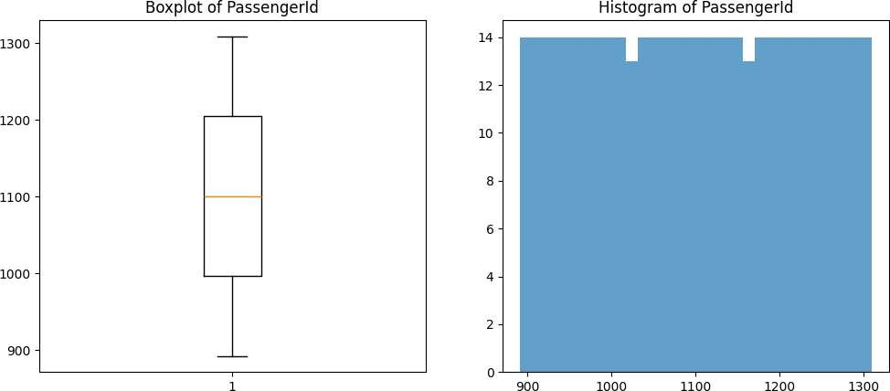

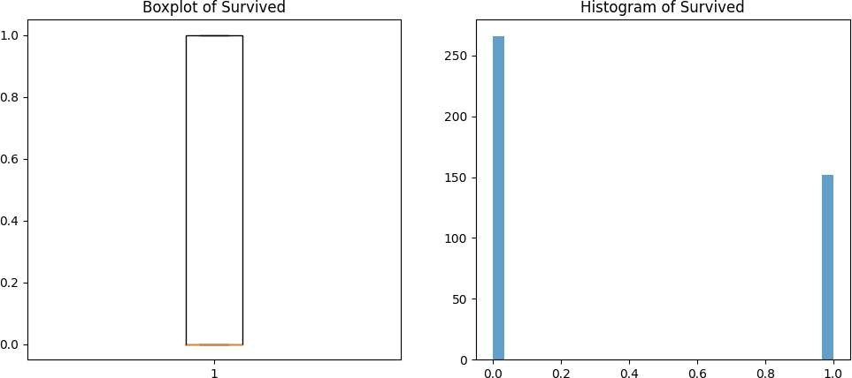

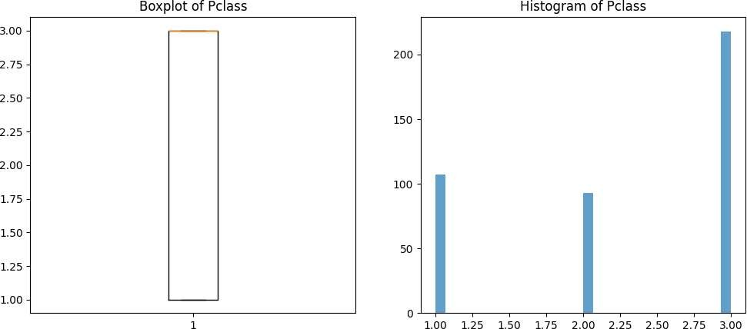

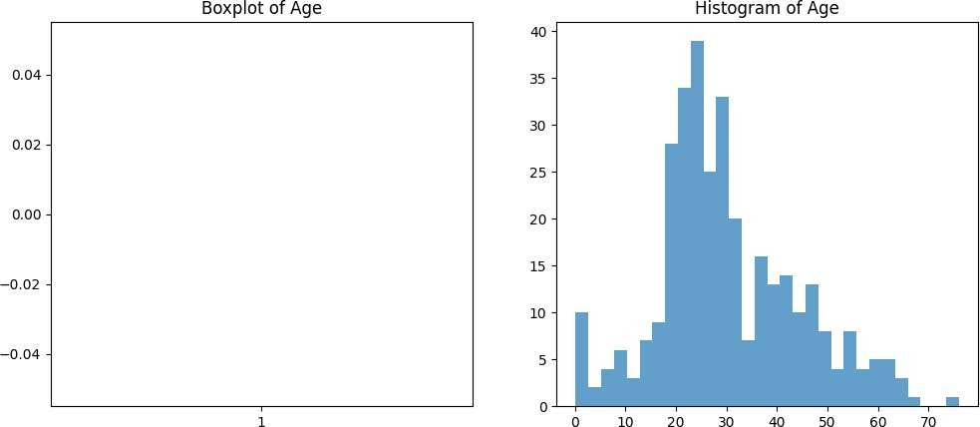

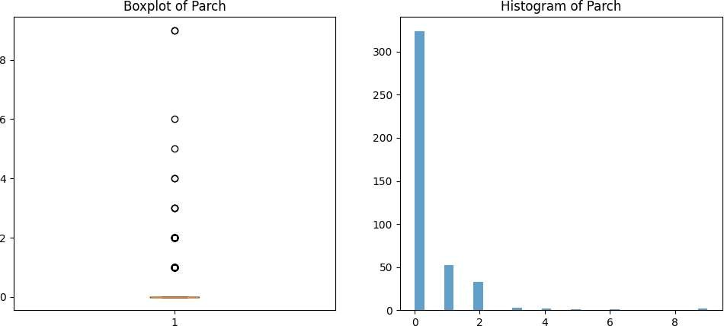
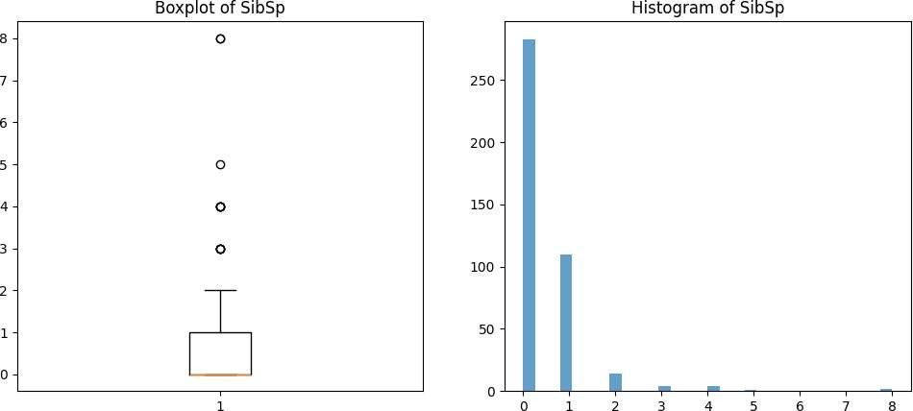

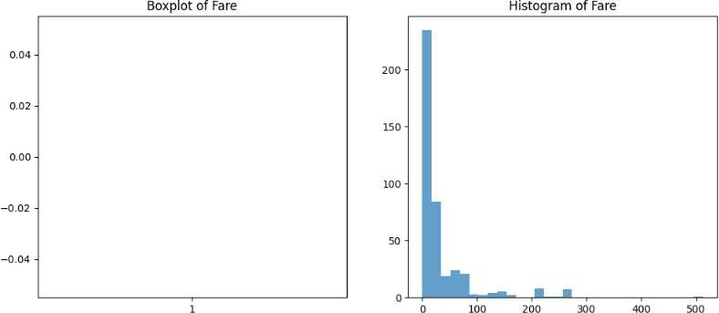

CORRELATION METRICS

PROGRAM

From itertools import combinations
import pandas as pd
importnumpy as np
# Load the dataset from a CSV file
dataset = pd.read_csv(r"C:\Users\Student\Downloads\archive (3)\CC GENERAL.csv")
# Mapper function to calculate correlation metrics
def mapper(dataset):
# Get only numerical columns from the dataset
numerical_columns = dataset.select_dtypes(include=[np.number])
# Store correlation results for all combinations
correlation_results = []
# Calculate Pearson, Spearman, and Kendall correlations
for each pair for col1, col2 in combinations(numerical_columns.columns, 2):
pearson_corr = numerical_columns[col1].corr(numerical_columns[col2], method='pearson')
spearman_corr = numerical_columns[col1].corr(numerical_columns[col2], method='spearman') kendall_corr = numerical_columns[col1].corr(numerical_columns[col2], method='kendall')
# Append the results as a tuple
correlation_results.append((col1, col2, pearson_corr, spearman_corr, kendall_corr))
return correlation_results
# Reducer function to simply return the mapped data (no further aggregation needed)
def reducer(mapped_data):
# Since the mapper already computes the correlations, the reducer can just return the results return mapped_data
# Step 3: Run MapReduce # Map step
mapped_data = mapper(dataset) # Reduce step
correlation_results = reducer(mapped_data)
# Convert the correlation results to a DataFrame for better readability
correlation_df = pd.DataFrame(correlation_results, columns=['Variable 1', 'Variable 2', 'Pearson', 'Spearman', 'Kendall'])
# Display the correlation results print(correlation_df)

OUTPUT:

Variable 1 Variable 2 Pearson Spearman Kendall

0 | BALANCE | BALANCE_FREQUENCY 0.322412 0.544981 0.429865
1 | BALANCE | PURCHASES 0.181261 0.006473 0.022283
2 | BALANCE | ONEOFF_PURCHASES 0.164350 0.145667 0.107438
3 | BALANCE | INSTALLMENTS_PURCHASES 0.126469 -0.089979 -0.056408
4 | BALANCE | CASH_ADVANCE 0.496692 0.565888 0.427766
.. ... ... ... ... ...
131 PAYMENTS PRC_FULL_PAYMENT 0.112138 0.187302 0.141349
132 PAYMENTS TENURE 0.106136 0.205412 0.163455
133 MINIMUM_PAYMENTS PRC_FULL_PAYMENT -0.140379 -0.478365 -0.358310
134 MINIMUM_PAYMENTS TENURE 0.059444 0.136618 0.108984
135 PRC_FULL_PAYMENT TENURE -0.016486 0.020244 0.01805

CLUSTERING OF A LARGE MULTI-VARIATE DATASET

PROGRAM
import numpy as np
import csv
file_path =r"C:\Users\Student\Downloads\Dataset.csv"
def load_data(file_path):
""" Load dataset from a CSV file into a NumPy array, skipping the header. """
with open(file_path, 'r') as file:
reader = csv.reader(file)
header = next(reader)
# Skip the header
data = []
for row in reader:
try:
# Convert numeric columns to float; assuming the first column is an ID
numeric_row = [float(value) for value in row[1:]]
# Adjust indexing based on your data
data.append(numeric_row)
exceptValueError:
continue
# Skip rows with non-numeric values
return np.array(data)
def initialize_centroids(data, k):
""" Randomly initialize centroids from the dataset. """
indices = np.random.choice(data.shape[0], k, replace=False)
return data[indices]
def map_phase(data, centroids):
""" Map phase: Assign each point to the nearest centroid. """
clusters = {i: [] for i in range(len(centroids))}
for point in data:
distances = np.linalg.norm(point - centroids, axis=1)
closest_centroid = np.argmin(distances)
clusters[closest_centroid].append(point)
return clusters defreduce_phase(clusters):
""" Reduce phase: Calculate new centroids from the clusters. """
new_centroids = []
For cluster_points in clusters.values():
If cluster_points:
# Check if the cluster is not empty
new_centroid = np.mean(cluster_points, axis=0) new_centroids.append(new_centroid)
else:
new_centroids.append(np.random.rand(len(cluster_points[0])))
# Random initialization
Return np.array(new_centroids)
def kmeans(file_path, k, max_iterations=100):
""" K-Means algorithm using a MapReduce-like approach. """
data = load_data(file_path)
centroids = initialize_centroids(data, k)
for iteration in range(max_iterations):
clusters = map_phase(data, centroids)
new_centroids = reduce_phase(clusters)
if np.all(centroids == new_centroids):
break
centroids = new_centroids
return centroids, clusters
if name == ' main ':
# Path to your dataset
file_path = r"C:\Users\Student\Downloads\Data set (1).csv"

k = 3
# Number of clusters (you can adjust this based on your needs)
final_centroids, final_clusters = kmeans(file_path, k)
print("Final Centroids:")
print(final_centroids)
print("Clusters:")
for cluster_id, points in final_clusters.items():
print(f"Cluster {cluster_id}:")
print(np.array(points))
# Convert to NumPy array for better readability

OUTPUT:

Final Centroids:
[[4.83301557e+03 9.14620970e-01 1.05307798e+04 7.42990541e+03 3.10103977e+03 5.43050951e+03 7.42298917e-01 5.86638699e-01
5.97387970e-01 2.30828677e-01 9.25563910e+00 8.44135338e+01
1.24890977e+04 1.79058694e+04 2.47407345e+03 3.29256820e-01
1.18421053e+01]
[3.42346862e+03 9.46718838e-01 1.60033818e+03 9.97705933e+02 6.02950444e+02 2.10615966e+03 5.44120884e-01 3.18911864e-01
3.89734613e-01 2.11820479e-01 5.79111111e+00 2.24164444e+01
8.98909091e+03 2.92089034e+03 1.58035601e+03 1.36138769e-01
1.17417778e+01]
[8.76792372e+02 8.76021309e-01 6.16390905e+02 3.18393259e+02 2.98309285e+02 4.99693396e+02 4.73446067e-01 1.57149088e-01
3.56433236e-01 1.08916299e-01 2.29617783e+00 1.09008476e+01
2.74528604e+03 1.03266735e+03 5.72410795e+02 1.64024103e-01
1.14532225e+01]]
Clusters:
Cluster 0:
[[1.41160223e+03 4.54545000e-01 9.63240000e+02 7.19948985e+02
3.33333000e-01 1.20000000e+01]
[2.99042219e+03 9.09091000e-01 4.52327000e+03 1.10703080e+03
4.54545000e-01 1.20000000e+01]
[2.39291774e+03 1.00000000e+00 1.24624400e+04 2.00099092e+03
0.00000000e+00 1.20000000e+01]

CLASSIFICATION OF A LARGE MULTI-VARIATE DATASET

PROGRAM

import numpy as np
import pandas as pd
# Path to your dataset
file_path=r"C:\Users\Student\Downloads\iris[1].csv" defload_data(file_path):
"""Load the Iris dataset from a CSV file."""
Return pd.read_csv(file_path)
Def euclidean_distance(point1, point2):
"""Calculate the Euclidean distance between two points.""" returnnp.sqrt(np.sum((point1 - point2) ** 2)) def map_phase(training_data, test_point, k):
"""Map phase: Calculate distances from the test point to all training points."""
distances = []
for index, row in training_data.iterrows():
distance = euclidean_distance(row[:-1], test_point)
# Exclude label
distances.append((distance, row[-1]))
# Store distance and label
distances.sort(key=lambda x: x[0])
# Sort by distance
return distances[:k]
# Return the k nearest neighbors def reduce_phase(nearest_neighbors):
"""Reduce phase: Determine the most common class among the nearest neighbors."""
classes = {}
for _, label in nearest_neighbors:
classes[label] = classes.get(label, 0) + 1
return max(classes, key=classes.get)
# Return the class with the highest count
def knn_classify(training_data, test_data, k):
"""KNN classification using a MapReduce-like approach.""" predictions = []
for index, test_point in test_data.iterrows():
nearest_neighbors = map_phase(training_data, test_point[:-1], k) predicted_class = reduce_phase(nearest_neighbors) predictions.append(predicted_class)
return predictions
if name == ' main ': # Load the dataset
iris_data = load_data(file_path)
# Split the data into training and test sets
training_data = iris_data.sample(frac=0.8, random_state=42)
# 80% for training test_data = iris_data.drop(training_data.index) # 20% for testing
# Number of neighbors k = 3
# Classify test data
predictions = knn_classify(training_data, test_data, k)
# Display predictions
print("Predictions for the test set:") print(predictions)
# Optionally, you can also check the actual classes
print("Actual classes:")
print(test_data.iloc[:, -1].values)

OUTPUT:
Predictions for the test set:
['setosa', 'setosa', 'setosa', 'setosa', 'setosa', 'setosa', 'setosa', 'versicolor', 'versicolor', 'versicolor', 'versicolor', 'versicolor', 'versicolor', 'versicolor', 'versicolor', 'versicolor', 'versicolor', 'versicolor', 'virginica', 'virginica', 'versicolor', 'virginica', 'virginica', 'virginica', 'virginica', 'virginica', 'virginica', 'virginica', 'virginica', 'virginica']
Actual classes:
['setosa' 'setosa' 'setosa' 'setosa' 'setosa' 'setosa' 'setosa' 'versicolor' 'versicolor' 'versicolor' 'versicolor' 'versicolor' 'versicolor' 'versicolor' 'versicolor' 'versicolor' 'versicolor' 'versicolor' 'virginica' 'virginica' 'virginica' 'virginica' 'virginica' 'virginica' 'virginica' 'virginica' 'virginica' 'virginica' 'virginica' 'virginica']

SPARK PROGRAM TO COMPUTE BOX-PLOTS AND HISTOGRAMS OF ALL THE NUMERICAL VARIABLES IN A LARGE DATASET

PROGRAM

1.Spark program for boxplot
From pyspark.sql import SparkSession
Import matplotlib.pyplotasplt

# Initialize Spark session
spark = SparkSession.builder.appName("BoxplotHistogramExample").getOrCreate()

# Sample data (replace with your actual dataset)
data = [
(1,23.5),
(2,19.0),
(3,21.5),
(4,25.0),
(5,18.0),
(6,22.5),
(7,24.0),
(8,23.0),
(9,21.0),
(10,20.5)
]

# Create DataFrame
columns = ["id","value"]
df = spark.createDataFrame(data, columns)

# Collect values into a list for visualization
values = df.select("value").rdd.flatMap(lambda x: x).collect()

# Plot histogram
plt.figure(figsize=(10,5))
plt.hist(values, bins=10,color='skyblue',edgecolor='black')
plt.title("Histogram of Values")
plt.xlabel("Value")
plt.ylabel("Frequency")
plt.show()

# Plot boxplot
plt.figure(figsize=(10,5))
plt.boxplot(values,vert=False,patch_artist=True)
plt.title("Boxplot of Values")
plt.xlabel("Value")
plt.show()

# Stop the Spark session
spark.stop()

OUTPUT:
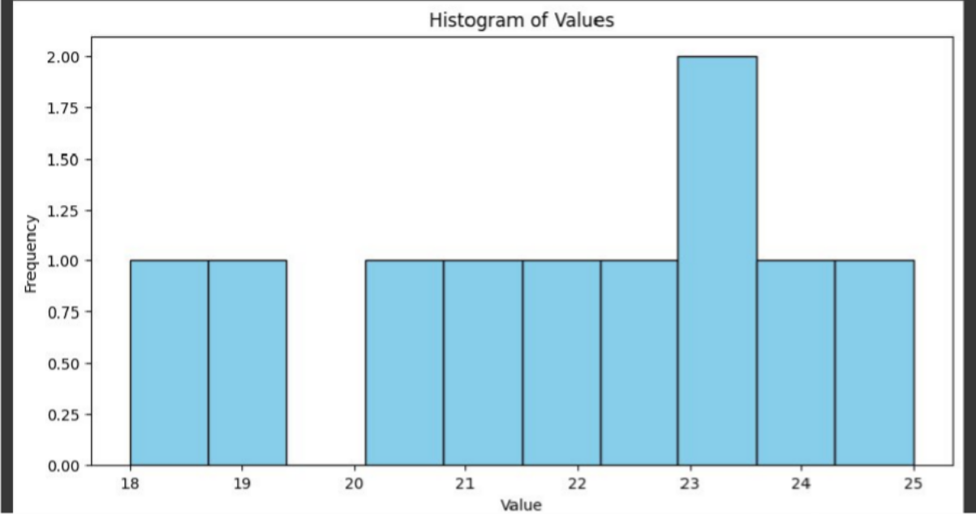

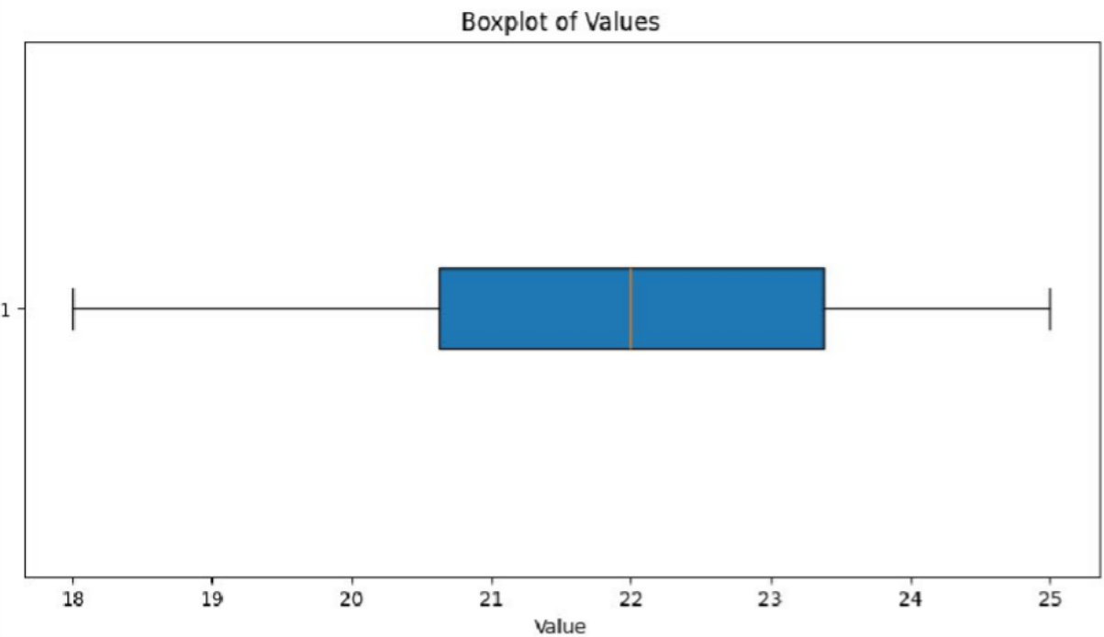

SPARK PROGRAM TO PERFORM CLASSIFICATION IN A LARGE DATASET

PROGRAM

From pyspark.sql import SparkSession
From pyspark.ml.classification import LogisticRegression
From pyspark.ml.feature import VectorAssembler
From pyspark.sql import Row

# Initialize Spark session
spark = SparkSession.builder.appName("ClassificationExample").getOrCreate()

# Sample data (replace or expand as needed)
data = [
Row(feature1=1.0, feature2=2.0, label=0),
Row(feature1=2.0, feature2=1.5, label=0),
Row(feature1=3.0, feature2=3.5, label=1),
Row(feature1=4.0, feature2=5.0, label=1),
Row(feature1=5.0, feature2=3.0, label=1),
Row(feature1=6.0, feature2=6.0, label=1),
Row(feature1=7.0, feature2=8.0, label=1),
Row(feature1=0.5, feature2=1.0, label=0),
Row(feature1=1.5, feature2=2.5, label=0)
]
# Create DataFrame
df = spark.createDataFrame(data)
df.show()

# Step 1: Assemble features into a single vector column
assembler = VectorAssembler(inputCols=["feature1", "feature2"], outputCol="features")
df = assembler.transform(df)

# Step 2: Prepare the data for training
# Select only the 'features' and 'label' columns
df = df.select("features", "label")

# Step 3: Split the data into training and testing sets
train_data, test_data = df.randomSplit([0.8, 0.2], seed=123)

# Step 4: Define and fit the logistic regression model
lr = LogisticRegression(featuresCol="features", labelCol="label")
lr_model = lr.fit(train_data)

# Step 5: Make predictions on the test set
test_predictions = lr_model.transform(test_data)
test_predictions.select("features", "label", "prediction", "probability").show()

# Step 6: Evaluate the model
# Print the coefficients and intercept of the model
print("Coefficients:", lr_model.coefficients)
print("Intercept:", lr_model.intercept)

# Evaluate model performance on test data
# Compute accuracy
accuracy = test_predictions.filter(test_predictions.label == test_predictions.prediction).count() / test_data.count()
print("Accuracy:", accuracy)

# Stop Spark session
spark.stop()

OUTPUT:

--------+--------+-----+
|feature1|feature2|label|
+--------+--------+-----+
| 1.0| 2.0| 0|
| 2.0| 1.5| 0|
| 3.0| 3.5| 1|
| 4.0| 5.0| 1|
| 5.0| 3.0| 1|
| 6.0| 6.0| 1|
| 7.0| 8.0| 1|
| 0.5| 1.0| 0|
| 1.5| 2.5| 0|
+--------+--------+-----+

+---------+-----+----------+--------------------+
| features|label|prediction| probability|
+---------+-----+----------+--------------------+
|[3.0,3.5]| 1| 0.0|[0.54281284112144...|
|[5.0,3.0]| 1| 1.0|[7.52656390841942...|
+---------+-----+----------+--------------------+

Coefficients: [6.585983453790336,7.011767177400992]
Intercept: -44.470807222059115
Accuracy: 0.5

SPARK PROGRAM TO PERFORM REGRESSION IN A LARGE DATASET

PROGRAM

From pyspark.sql importSparkSession
From pyspark.ml.regression importLinearRegression
From pyspark.ml.feature importVectorAssembler
From pyspark.sql import Row

# Initialize Spark session
spark = SparkSession.builder.appName("LinearRegressionExample").getOrCreate()

# Sample data (replace or expand as needed)
data = [
Row(feature1=1.0, feature2=2.0, label=3.0),
Row(feature1=2.0, feature2=1.0, label=2.5),
Row(feature1=3.0, feature2=3.0, label=6.0),
Row(feature1=4.0, feature2=5.0, label=9.0),
Row(feature1=5.0, feature2=3.0, label=7.5),
Row(feature1=6.0, feature2=6.0, label=12.0),
Row(feature1=7.0, feature2=8.0, label=15.0)
]

# Create DataFrame
df = spark.createDataFrame(data)
df.show()

# Step 1: Assemble features into a single vector column
assembler = VectorAssembler(inputCols=["feature1","feature2"],outputCol="features")
df = assembler.transform(df)

# Step 2: Prepare the data for training
# Select only the 'features' and 'label' columns
df = df.select("features","label")

# Step 3: Split the data into training and testing sets
train_data,test_data = df.randomSplit([0.8,0.2], seed=123)

# Step 4: Define and fit the linear regression model
lr = LinearRegression(featuresCol="features",labelCol="label")
lr_model = lr.fit(train_data)

# Step 5: Make predictions on the test set
test_predictions = lr_model.transform(test_data)
test_predictions.select("features","label","prediction").show()

# Step 6: Evaluate the model
print("Coefficients:",lr_model.coefficients)
print("Intercept:",lr_model.intercept)

# Evaluate model performance on test data
test_summary = lr_model.evaluate(test_data)
print("RMSE:",test_summary.rootMeanSquaredError)
print("R2:", test_summary.r2)

# Stop Spark session
spark.stop()

OUTPUT:

--------+--------+-----+
|feature1|feature2|label|
+--------+--------+-----+
| 1.0| 2.0| 3.0|
| 2.0| 1.0| 2.5|
| 3.0| 3.0| 6.0|
| 4.0| 5.0| 9.0|
| 5.0| 3.0| 7.5|
| 6.0| 6.0| 12.0|
| 7.0| 8.0| 15.0|
+--------+--------+-----+

+---------+-----+------------------+
| features|label| prediction|
+---------+-----+------------------+
|[3.0,3.0]| 6.0| 5.789473684210524|
|[6.0,6.0]| 12.0|11.828947368421058|
+---------+-----+------------------+

Coefficients: [0.825657894736843,1.1875000000000018]
Intercept: -0.2500000000000109
RMSE: 0.19180762811990992
R2: 0.9959122037550016

